Primary Source Tool Kit

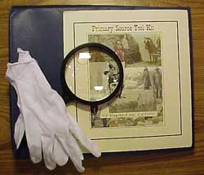
There are times when we simply have to "hold" a resource, touch it, and see it first hand. Since most students and teachers will not have an opportunity to visit the Library of Congress, it is necessary to bring this experience to your classroom. Primary Source Toolkits can do this!
To construct a Primary Source Toolkit, high quality images can be printed out on card stock, at full size. If you are unable to create adequate prints at your school site, the images can be saved to a zip or floppy disk and taken to a duplication service (like Kinko's). The images can be stored in a "portfolio" file along with a magnifying glass and a set of white, cotton gloves. A pair of student “partners” or a small group can share this toolkit. Below are some basic tips for viewing documents and other primary source materials.

White Gloves

Wash your hands before handling any artifact. Wearing white cotton gloves prevents the oils and salts on your hands from damaging artifacts. So, it is important that white gloves are part of your preservation tool kit. Listed below are some Library of Congress guidelines for handling different resources. You will note that in some cases white gloves are not worn.

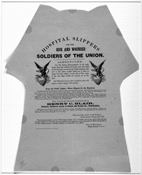

Paper Materials: Hands should be clean and dry before handling paper items, as the oils from fingers can cause staining on the paper. Avoid having food or drinks in the area of your collection. Use pencils when working with your collection, to avoid possible disfigurement from inks.

Books: If a book will not lay flat, do not use force to open it further. The covers should always be supported when the book is open

Hospital slippers for the sick and wounded soldiers of the Union
Courtesy The Library of Congress

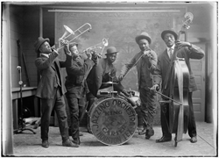
Photographic Materials: If photographs are handled improperly, they can suffer disastrous damage, including tears, cracks, losses, abrasions, fingerprints, and stains. Avoid touching fragile photographic materials; salts in human perspiration may damage surfaces. Wear clean cotton gloves if possible when handling negatives and prints.
Recorded Sound: Do not touch the playing surface/s of any recording. Handle recordings by their outer edges.
King Carter Jazzing Orchestra
Courtesy The Library of Congress
Film: Film should always be held by its edges to avoid leaving fingerprints on picture and sound areas.

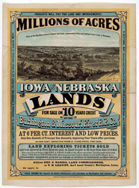
Magnifying Glass
Viewing small print is made easier by using a magnifying glass. You can also observe more detail in photographs.
Pencil and Paper

You will want to make notes of your observations while examining primary source materials. Most libraries do not allow the use of pens so you want to be sure to have a pencil.
Millions of Acres
Courtesy The Library of Congress

