Worksheet – Lesson 1
Circumference of Circles

Name:____________________

1) Fill out this chart as you go over the questions in Step 2 of Lesson 1

Shape | Radius (in.) | Diameter (in.) | Circumference (in.)
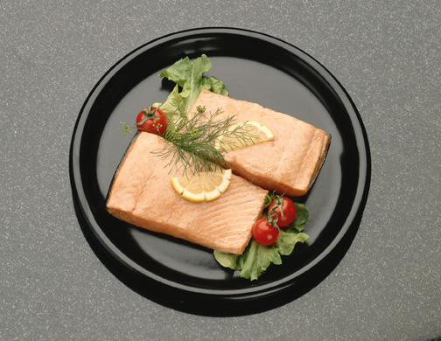

Dinner plate

CD

Top of
soft-drink can

2) Compare the dimensions of the plate, the CD, and the soft-drink can. What happens to the circumference of a circle when you double its diameter? Use the space below to explain your answer in detail.

