Name________________________________
ICE-CREAM CONES
An ice-cream parlor has eight flavors of ice cream:
Vanilla | Chocolate | Strawberry | Cookies 'n Cream
Nutty Coconut, | Butter Pecan | Pralines 'n Cream | Mint Chocolate Chip
How many different double-dip cones can be made?
**It does not matter what order the flavors are placed on the cones. For example, the two cones below are NOT two different cones because they both use the same flavors of Vanilla and Lime. | 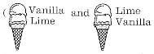
GUESS:____________________
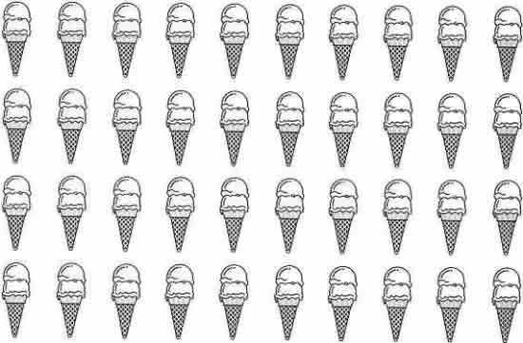
CONCLUDE:__________________

